

Crossover Technical Trial
TECHNICAL DESIGN DOCUMENT

Number Prettifier

October 25, 2015
Carlos Carrascal Sánchez

Revision History

Version |  | Changes | Author
#. | Date | Changes | Author
1 | 25/10/2015 | Initial version | Carlos Carrascal

Index
1Revision History 2
2Index 2
3Introduction 3
4Technical overview 4
4.1.System characteristics 4
4.2.Dependencies 4
5System design 5
5.1.Files structure 5
5.2.System architecture 6
6Component description 7
6.1.Functional overview 7
6.1.1Regionalization 7
6.1.2Rounding 8
6.1.3Error control 8
6.2.NumberPrettifier class 9
6.3.NumberPrettifierTest JUnit Test class 11
6.4.Ant build file (build.xml) 12

Introduction
This document describes the technical design used to develop an application requested by Crossover for a Technical trial.

The project will be developed using Java programming language, and the resulting product will be a Java class named NumberPrettifier included in package org.crossover.util.

The deliverables for this project will include:

- Technical design document (this document).
- Source code
- A demonstration video
- A readme.txt file with compiling and running information

The project aim is to develop a component to format numbers using a special truncated format with the number followed by a letter, indicating millions, billions or trillions.

The key design points used in this project are as follows:

- Keep it simple. The expected functionality is relatively simple, allowing us to generate a small component.
- Lightweight project using the minimal external dependencies.
- Easy of use, integrate and maintenance.

Technical overview
This section will provide general system characteristics, architecture, dependencies, etc.

System characteristics
The project is developed in Java, using Java OpenJDK, version 7. The rest of components involved in are as follows:
- Java as programming language, using OpenJDK version 7. Oracle Java SE JDK7 or higher is also valid.
http://www.oracle.com/technetwork/es/java/javase/downloads/jdk7-downloads-1880260.html
http://openjdk.java.net/install/

- JUnit v4.12 for unit testing.
https://github.com/junit-team/junit/wiki/Download-and-Install
- Ant v1.9.6 as command line tool used to compile the project.
http://ant.apache.org/
- Development was made using a Debian 7 GNU / Linux box.
The resulting products are:

- Main class NumberPretiffier, included in package org.crossover.util
- JUnit test classes
- Javadoc documentation

Dependencies
The only Java dependencies needed for this project outside the JDK Java API is JUnit, and in shipped with the source code of the project.
One of the main goals of the project was to keep dependencies to a minimum, for simplicity's shake.

System design

Files structure
This section describes the files and folder structure used in the project. The following table details all components of the structure.
Folder or file name | Description
bin | Directory containing all Java classes files.
bin/org/crossover/util/ | Directory containing class of org.crossover.util package:  NumberPrettifier.class
bin/tests/org/crossover/util/ | Directory containing testing classes for org.crossover.util package.  NumberPrettifierTest.class  NumberPrettifierTestSuite.class
docs | Directory containing automatically generated Javadoc files
lib | Directory containing required dependency files, in JAR format.  The following files are included:  junit-4.12.jar  hamcrest-core-1.3.jar
src | Source files directory.  ExampleRunner.java : This is an example class that uses NumberPrettifier to display some formatting examples of use.
src/org/crossover/util | Source files for org.crossover.utl package  Contain the following files:  NumberPrettifier.java
test | Source files for JUnit test classes
test/org/crossover/util | Source files for org.crossover.util package test files.  NumberPrettifierTest.java  NumberPrettifierTestSuite.java
build.xml | Ant file used to compile the projejct, run tests and generate Javadoc files.
compile.sh | Bash shell script for simple compilation without Ant
runtest.sh | Bash shell script for running JUnit tests
run.sh | Bash shell script for running the example. This script executes the class RunningExample, and can receive as a parameter a number to prettify.

System architecture
The following architecture diagram shows the interaction of this software component with a Java application.

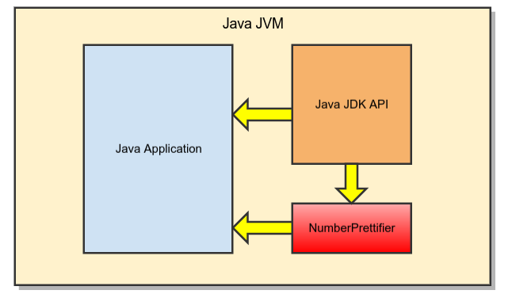
Any Java application can include this component by including the corresponding classes in their Classpath, and referencing the component using an import directive.

Component description
This section provides a functional overview of the project, as well as detailed information of all the components included in the project.

Functional overview
The main function of this project is the development of a Java class named NumberPrettifier, capable of formatting numbers. This class will be included in a package named org.crossover.util.
The class accepts a numeric type as an input and returns a truncated, "prettified" string version. The prettified version includes one number after the decimal when the truncated number is not an integer. It will prettify numbers greater than 6 digits supporting millions (M), billions (B) and trillions (T).
Short scale numbers are used to output the prettified number.
The following examples illustrates the expected output of the component.
input: 1000000 output: 1M

input: 2500000.34 output: 2.5M

input: 532 output: 532

input: 1123456789 output: 1.1B

To deal with decimal representation of the output formats, the JDK class DecimalFormat will be used using the pattern “#.#” to display only one decimal character.
Negative numbers are allowed and formated in the same way.

Regionalization
The DecimalFormat class used to display the results will format those results considering the available locales configured in the executing system. Depending on the locale used, the symbol used to represent the decimal separator may change.
In order to obtain consistent output and ensure the results of the unit tests, the component will use US locale by default.
The locale used can be specified in the class constructor, to adapt the results as needed.
As an example, the spanish locale uses the symbol “,” as decimal separator, instead of “.” used by US locale.

Rounding
In order to represent the truncated version of the input number, rounding will be used in the output formatting.
The rounding method to use will be java.math.RoundingMode.HALF_EVEN, which is used by default for the DecimalFormat class.
As per Java JDK documentation, this rounding method is as follows:
Rounding mode to round towards the "nearest neighbor" unless both neighbors are equidistant, in which case, round towards the even neighbor.

Error control
In case of errors during formatting, the class should return an empty value. No exception must be thrown from this class.
This class is expected to be used as a simple formatter. Returning an empty value in case of errors allow the calling class to control the final output without having to check for exceptions or interrupt in the normal execution flow.

NumberPrettifier class
This is the main component to be developed in this project. This class will perform the number formatting by using any of the convenience methods to be implemented.
The following image show the diagram for this class, that will be included in the package org.crossover.util.

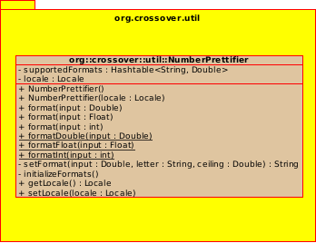

The class attributes and methods are as follows.

Attributes | Type | Description
locale | Locale | Private.  Locale used to format the output numbers. Used to determine the decimal separator character.
supportedFormats | Hashtable | Private.  Hastable containing pairs of key / value representing the formats to use.  The key will be the letter used to append to the result.  The value will be the ceiling value to determine when to apply this format. An input number greater or equal to the ceiling value will be formatted with it.  The formats have to be introduced in decreasing order to be processed correctly.

Method | Parameters | Return value | Description
NumberPrettifier | - | void | Empty constructor
NumberPrettifier | locale - Locale | void | Contructor with provided Locale
InitializeFormats | - | void | Initialize supportedFormats hashtable with predefined values.
format | input - Double | String | Public.  Main formating method.  Format a number into a truncated, "prettified" string version.  Negative numbers are allowed and formated in the same way.
setFormat | input – Double  letter – String  ceiling – Double | String | Private.  This function truncates the number as determined by <pre>ceiling</pre> parameter,  and uses a <pre>DecimalFormat</p> class to format the number if the resulting number  is not an integer, to represent it only with one decimal.  The decimal separator will be "." by default, unless a specific Locale was used in the constructor.
format | input - String | String | Public.  Helper function to format using a String.  Calls format(Double) internally.
format | input - int | String | Public.  Helper function to format using a int.  Calls format(Double) internally.
formatDouble | input - Double | String | Public, static.  This method does the same as format(Double) but can be called statically.
formatFloat | input - Float | String | Public, static.  This method does the same as format(Double) but can be called statically.
formatInt | input - int | String | Public, static.  This method does the same as format(Double) but can be called statically.

NumberPrettifierTest JUnit Test class
A JUnit test class will be developed along with the main NumberPrettifier class. The tests implemented in this class will be included in the Ant file, so they can be executed automatically each time that the project is compiled.
This class will be included in the same org.crossover.package than the tested class, but will be placed in a separate “test” source directory.
This class will implement the following tests.

Test | Description
Basic test | Basic testing of the values provided as examples.
Negative values test | Same test for negative values
Different locale test | Same values with different locale
Wrong locale name test | With a incorrect locale, values must revert to US
Wrong values | Wrong string values should return empty string
Static method test | Test static methods with same values

Ant build file (build.xml)
An Ant file must be included in the project to control basic tasks:
- Compile the source code
- Execute unit tests
- Generate Javadoc from source files
The default action will be compile, test and generate Javadoc.

